DRIVER CONFIGURATION
OPEN
Configuring IE Driver:
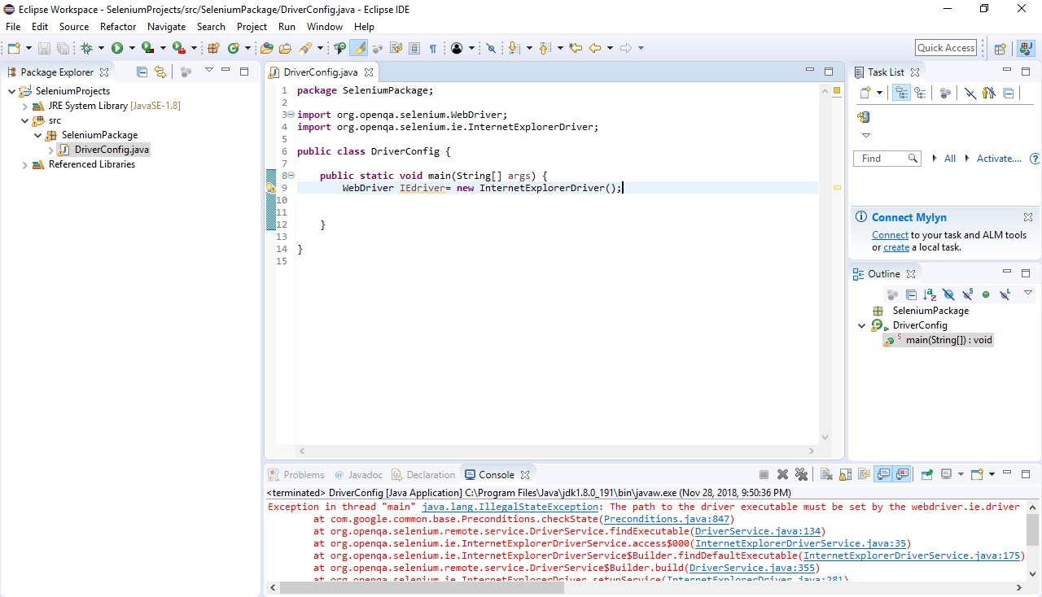

After Importing IEDriver.exe
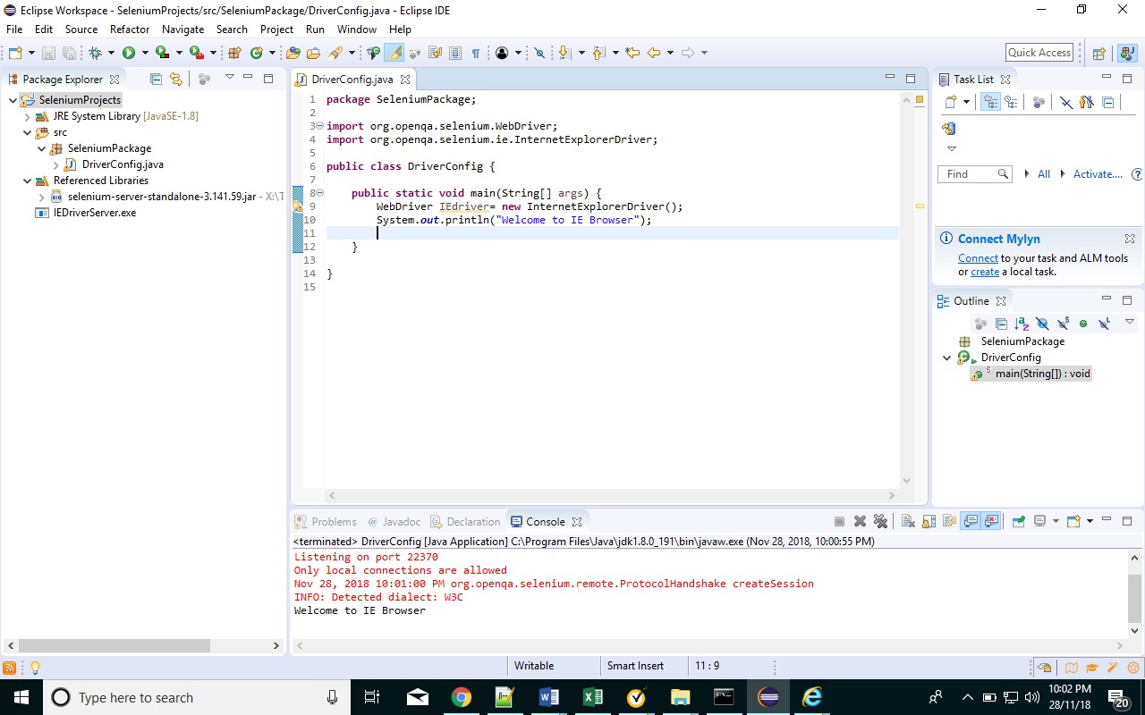
Configuring Chrome Driver:
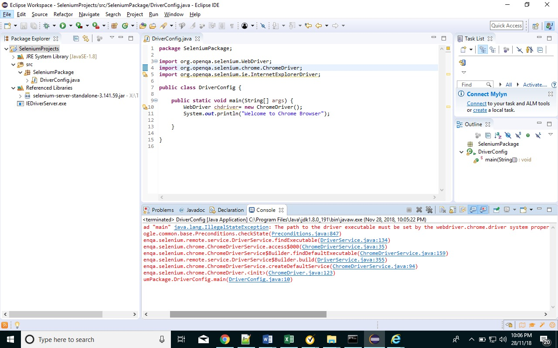
After Importing ChromeDriver.exe
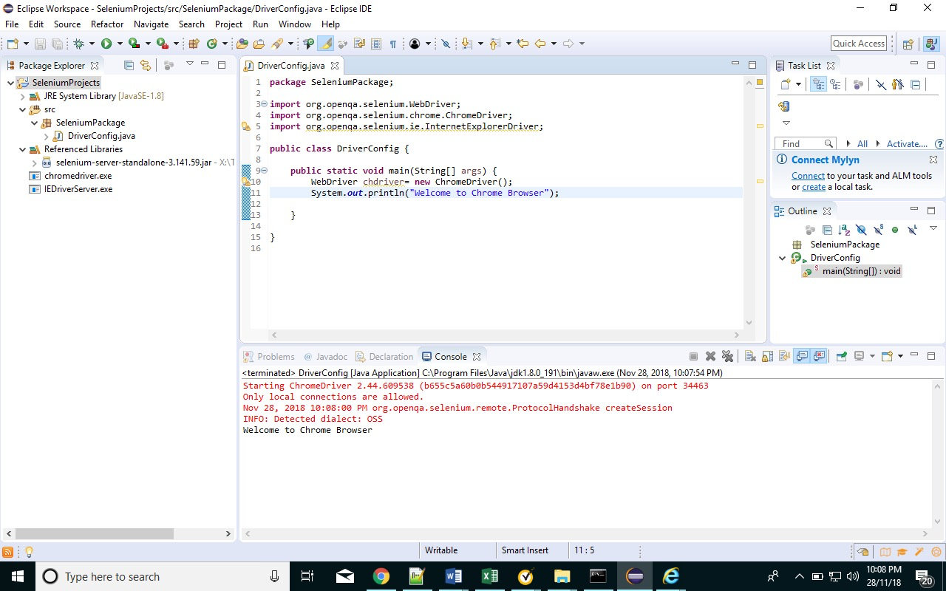

Also, we can add Drivers using System.setProperty
Kindly check attached “DriverConfig.java”

